Қызылсая орта мектебі

**АШЫҚ САБАҚ**

**Тақырыбы:** «My father's hobby»

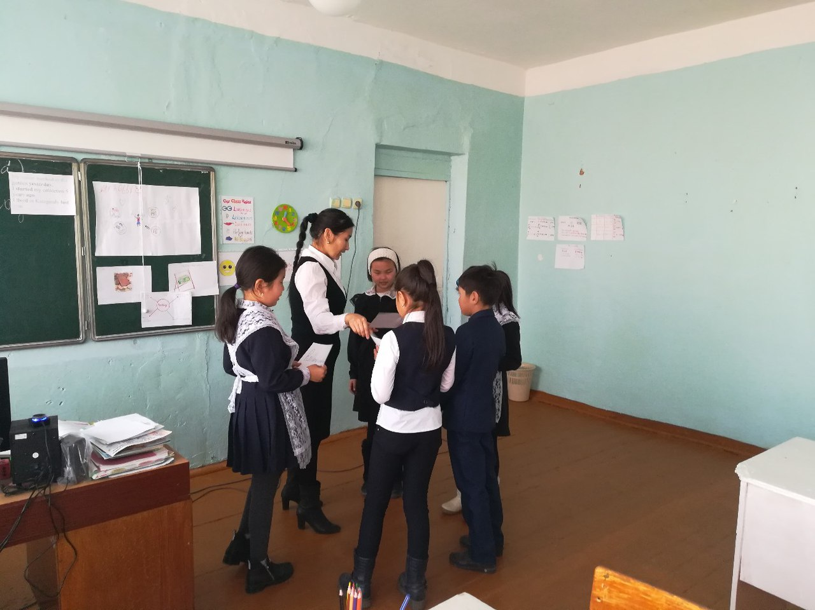

**Өткізген:** Каюпова Д.Д.

2016-2017 оқу жылы

**Date:**

**Grade: 4**

**The theme of the lesson: «My father's hobby»**   
**Literature: English 4 grade**   
**Aims of the lesson:** At the end of the lesson the students will be able to   
1. Identify regular verbs   
2. Discriminate long a sound   
3.Construct sentences with Past Simple   
**Results of teaching:** Students will work with groups   
Students will know about hobbies and about Alibek's fathers hobby   
Students will know about Past Simple and regular verbs   
Main ideas: Learning English new words and English grammar   
Тasks: 1st task-Dividing into three groups   
2nd task-English sounds. Listening audio disk   
3rd task- Exercises 2 and 3, page 24.   
4th task- Look at the pictures and answer the questions. Listen and read   
5th task-Answer the questions   
6th task-Grammar Past Simple   
7th task-exercise 7, page -7   
1st task.   
( 5 minutes) Dividing into three groups   
1st group´s name is-origami   
2nd group is- hobby   
3rd group is- collection   
Resources: Stickers   
2nd task.   
( 2 minutes) English sounds. Listening audio disk   
Listen and repeat long a a, ay, ai   
Rain, day, plane, play, train, Jane   
Resources: Audio disk. Computer   
3rd task   
( 10 minutes) Exercises 2 and 3, page 24.   
2.Read   
This is Jane.She likes rain.Today is her favourite day.It is a rainy day.She likes playing in rain.These are a train and a plane.Jane likes travelling by train and by plane   
3.Read and choose the words with a long a sound.   
May, paint, cat, stay, say, apple, ant, play, rain, hat, table, lady, candle, man, day.   
Resources: English 4 grade   
4th task   
( 10 minutes) Look at the pictures and answer the questions.Listen and read   
5th task   
(3 minutes) Answer the questions   
1. What is Alibek showing to his father?   
2. What is his father´s hobby?   
3. Is Alibek´s stamp old or new?   
4. How many stamps are there in Alibek´s fathers collection?   
6th task   
(3 minutes) Grammar Past Simple   
Past Simple. Positive form   
We use Past Simple to speak about actions in the past   
We use –ed, -d to make Past Simple   
Start-started   
Work-worked   
Live-lived   
My father worked in the garden yesterday   
I started my collection 5 years ago   
I lived in Karagandy last year   
7th task   
(2 minutes) exercise 7, page -7   
Liked   
Danced   
Helped   
Watched   
Talked   
Presented   
Assessment   
(5 minutes)   
Home task   
(5 minutes) Exercises 1,2, 3, pages 14-15   
Reflection   
Evaluation of the teacher